AMS E-Books使用指南
校园IP地址内打开浏览器，输入https://www.ams.org/publications/ebooks/ebooks，选择待查询书目。
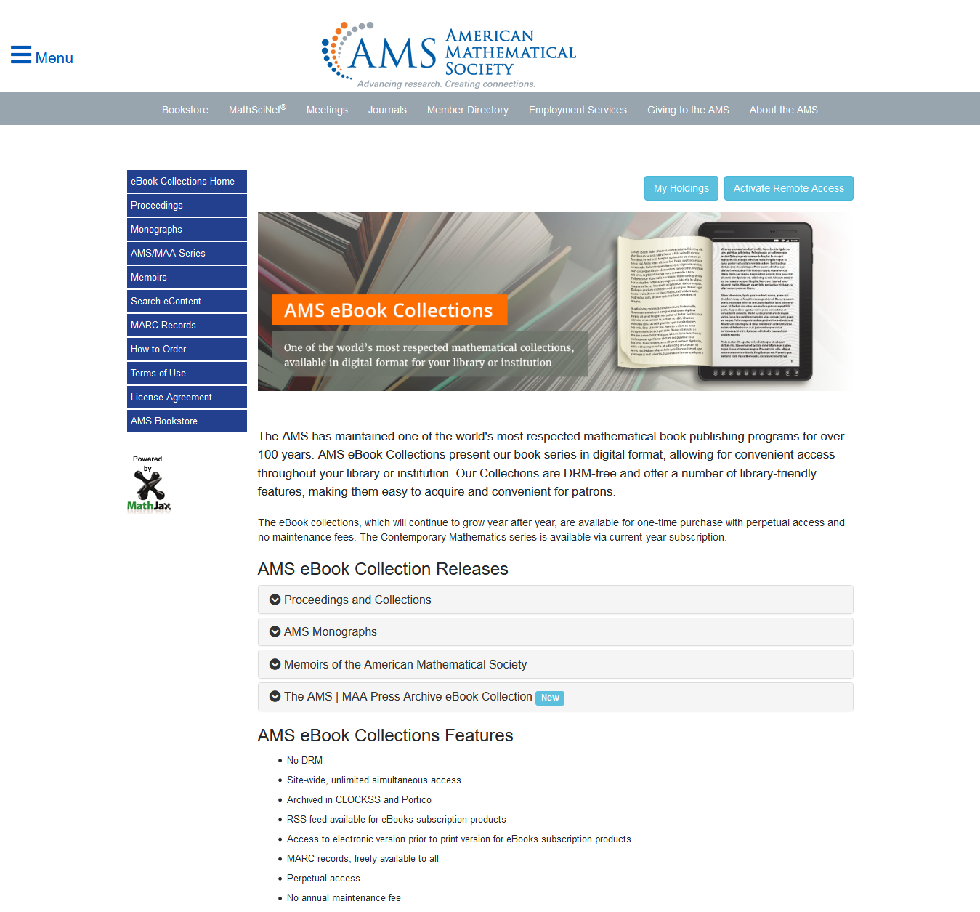
AMS将他们出版的电子书分为4个系列，会议录系列、专题论文系列、论文集系列、MAA 电子书合集，请下拉各个系列菜单，选择阅读该系列中已订购的二级系列的电子书

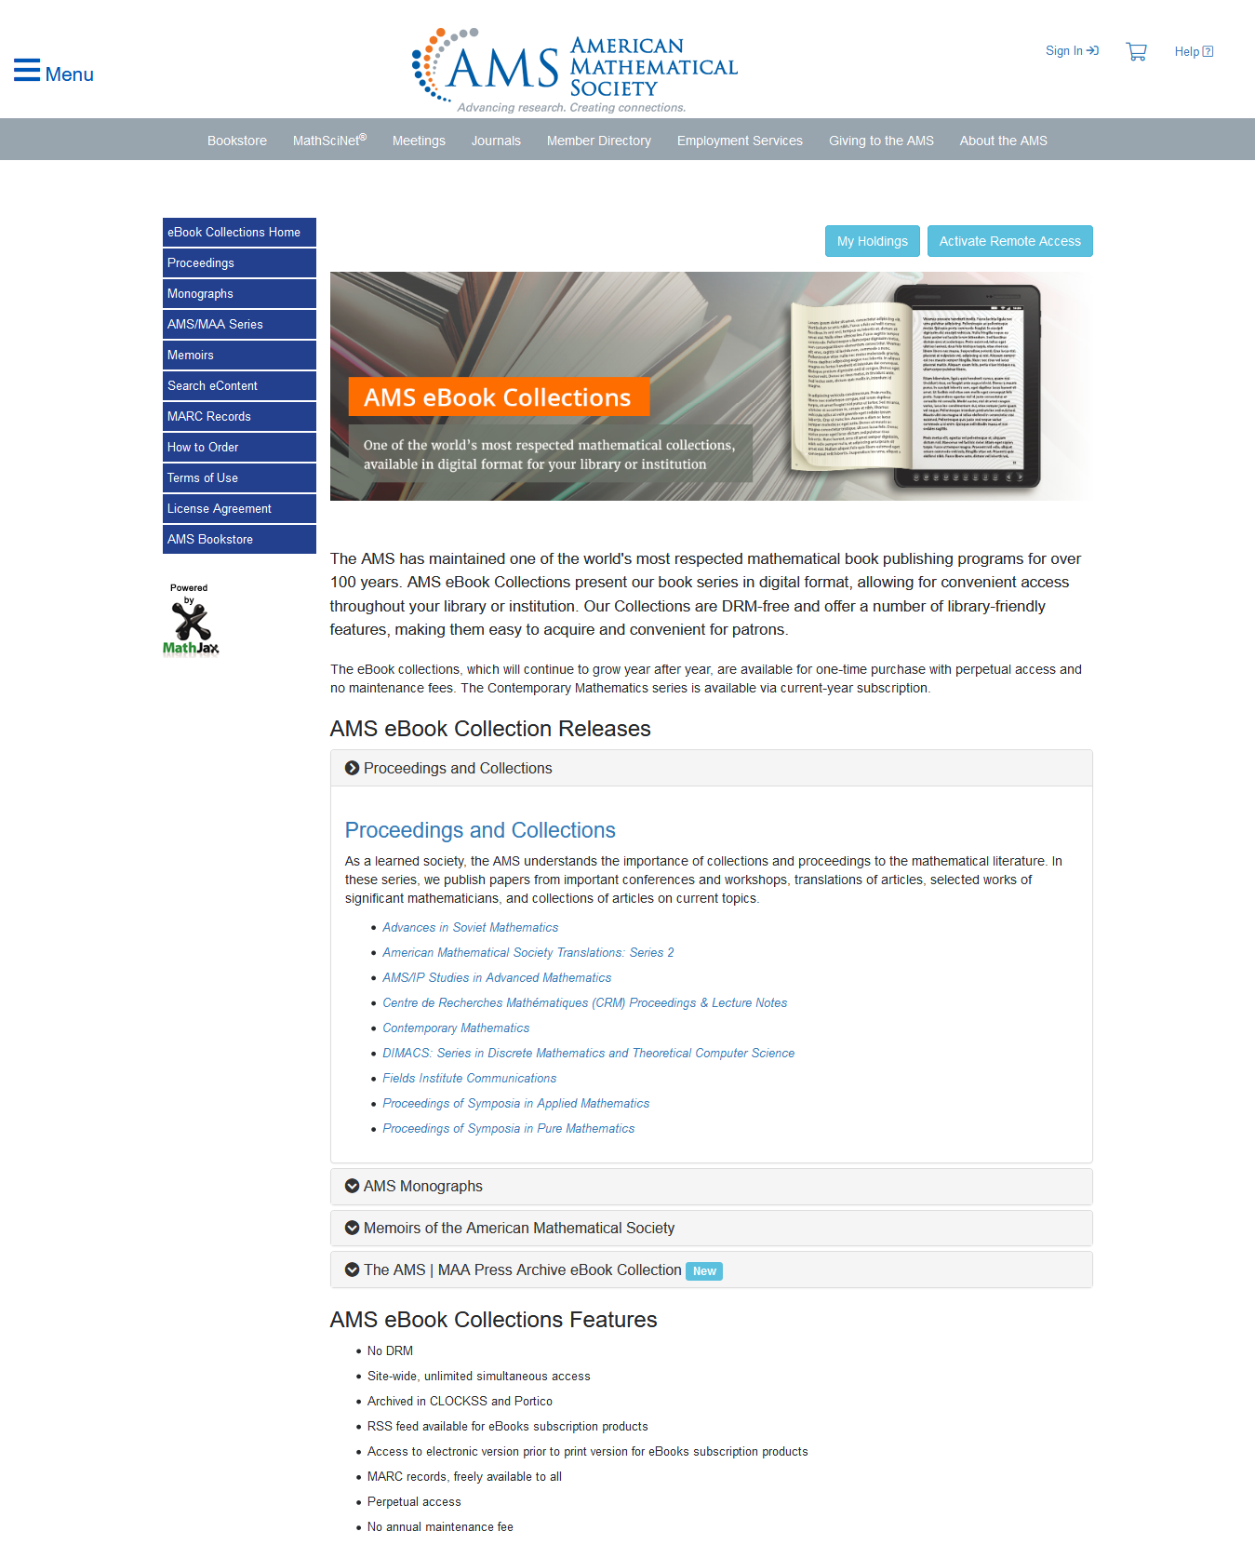
点击各个系列标题后，会出现每个系列包含的二级主题书目系列，以下提供苏州大学已订购系列的明细。
读者可以通过网页逐层进入阅读，也可以直接点击以下URL链接进入。

序号 | 已订购二级系列名称 | 所属一级系列 | URL | 购买年份
1 | 《当代数学》Contemporary Mathematics | Proceedings and Collections | https://www.ams.org/publications/ebooks/conm-coll | 1980-2020年
2 | 《应用数学研讨会论文集》Proceedings of Symposia in Applied Mathematics | Proceedings and Collections | https://www.ams.org/publications/ebooks/psapm-coll | 1949-2018年
3 | 《纯粹数学研讨会论文集》Proceedings of Symposia in Pure Mathematics | Proceedings and Collections | https://www.ams.org/publications/ebooks/pspum-coll | 1959-2019年
4 | 《数学调查与专著》Mathematical Surveys and Monographs | AMS Monographs | https://www.ams.org/publications/ebooks/surv-mon | 1943-2019年
5 | 《Barry Simon综合分析课程》A Comprehensive Course in Analysis by Barry Simon | AMS Monographs | https://www.ams.org/publications/ebooks/simon-mon | 2015年
6 | 《研讨会出版物》Colloquium Publications | AMS Monographs | https://www.ams.org/publications/ebooks/coll-mon | 1905-2019年
7 | 《研究生数学》Graduate Studies in Mathematics | AMS Monographs | https://www.ams.org/publications/ebooks/gsm-mon | 1993-2019年
8 | 《学生数学图书馆》Student Mathematical Library | AMS Monographs | https://www.ams.org/publications/ebooks/stml-mon | 1999-2019年
9 | 《大学讲座系列》University Lecture Series | AMS Monographs | https://www.ams.org/publications/ebooks/ulect-mon | 1989-2019年
10 | 《数学专著翻译版》Translations of Mathematical Monographs | AMS Monographs | https://www.ams.org/publications/ebooks/mmono-mon | 1962-2018年
11 | 《IAS普林斯顿高等研究所PCMI系列》IAS/Park City Math Inst Series | AMS Monographs | https://www.ams.org/publications/ebooks/pcms-mon | 1995-2019年

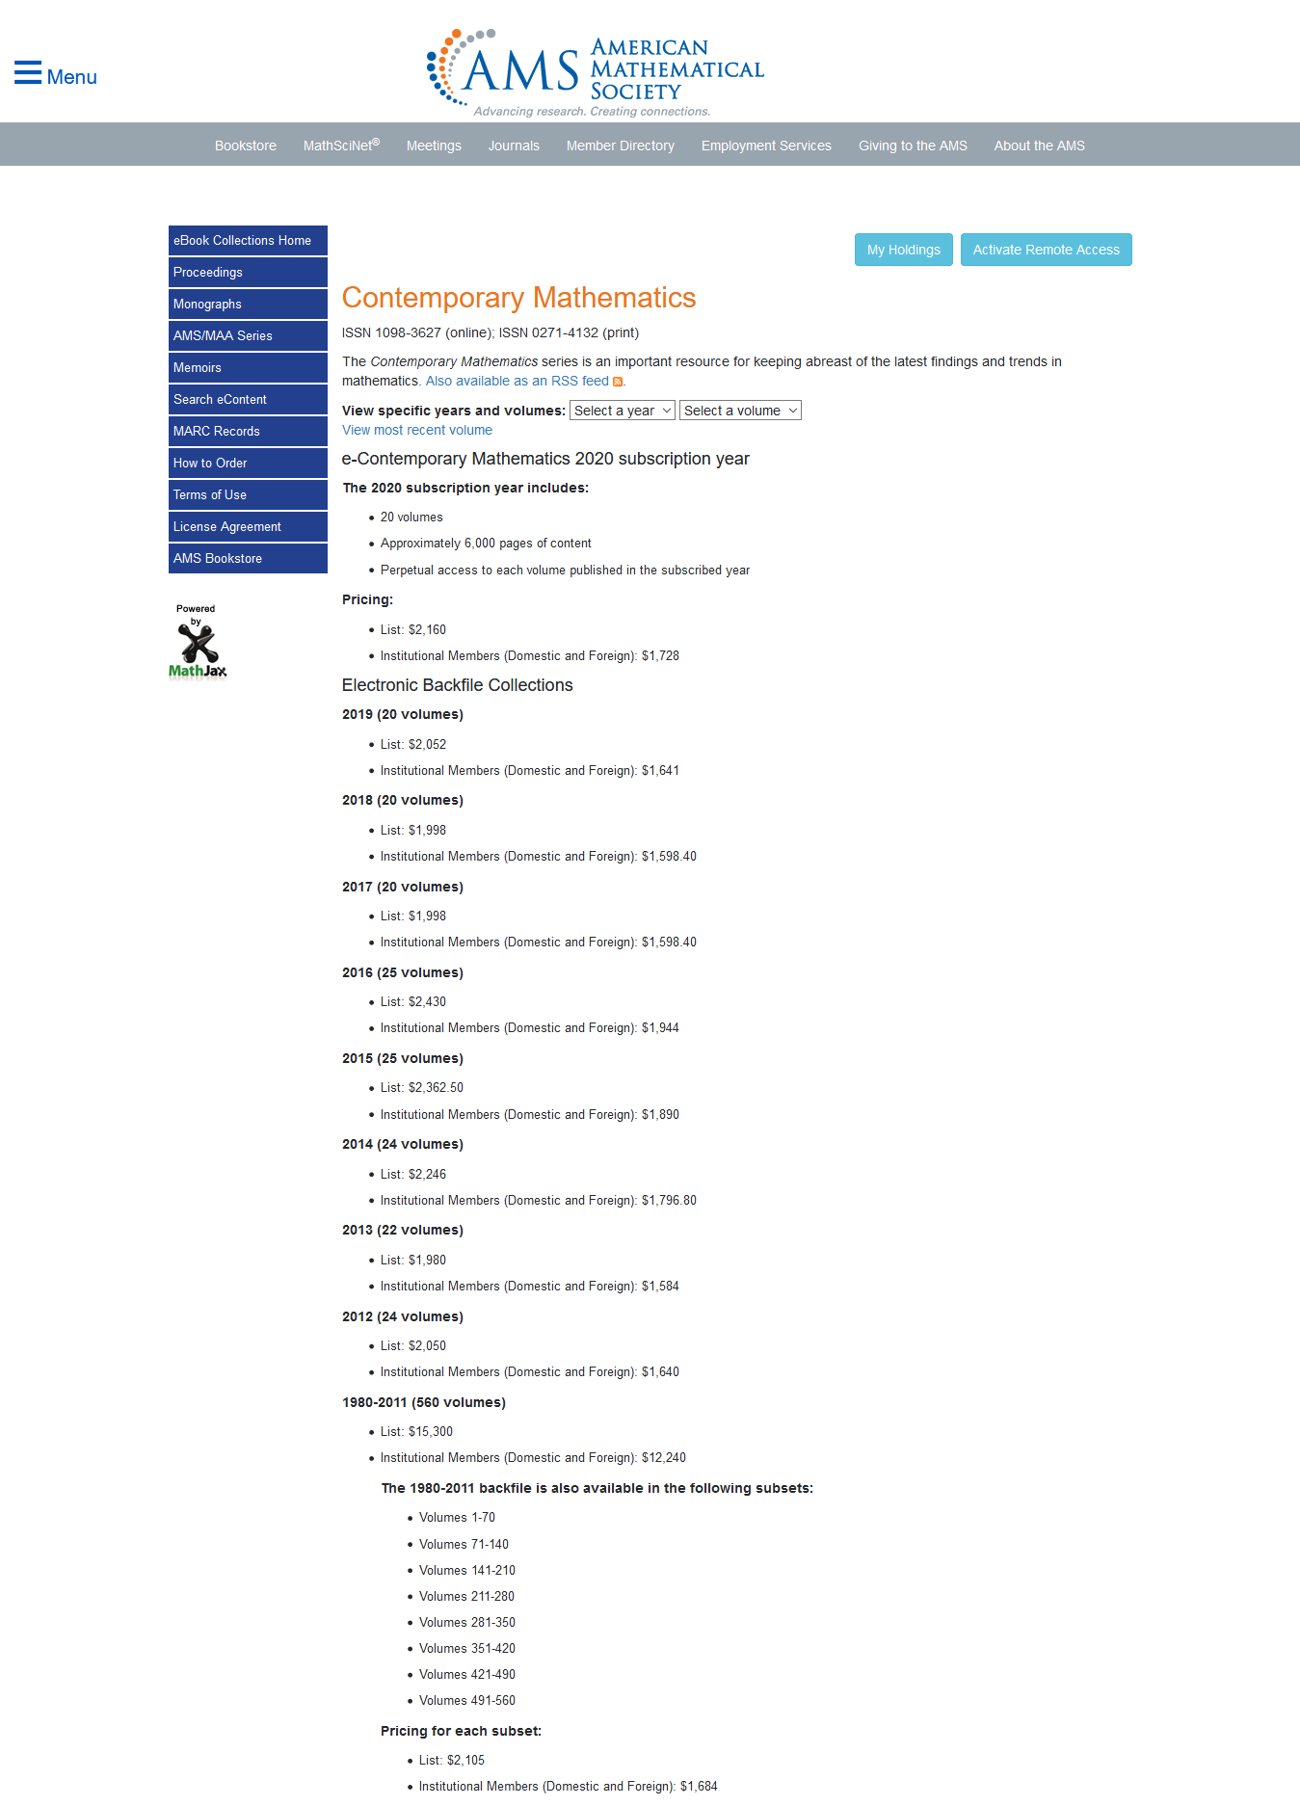
进入二级丛书系列后，可以根据年份和卷期进行二次筛选处理。

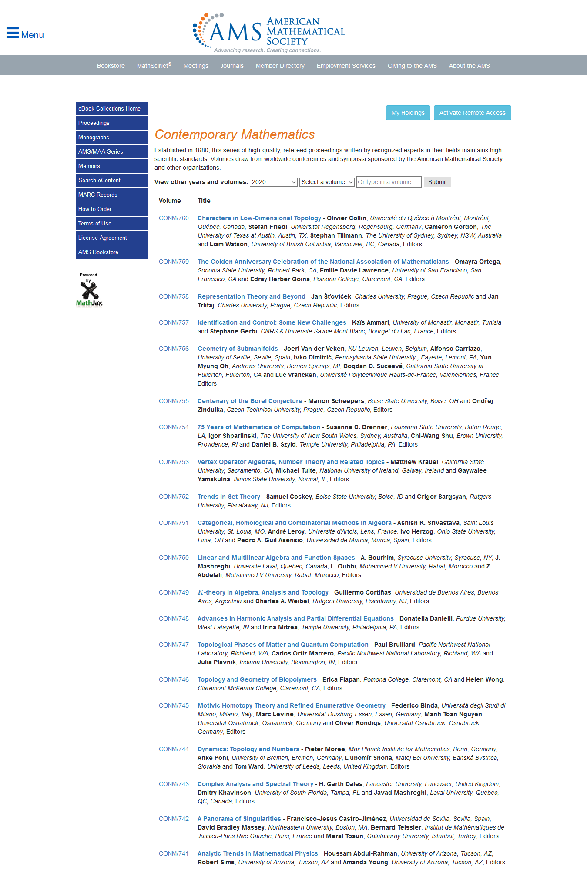
现在可以按你感兴趣的书目选择阅读啦~

